**Anisotropic Quarter Punch Test: An optimized geometry replacement for the anisotropic small punch test**

K. J. Boatwright, G. A. Von Forell, P. Hyoung, *A.E. Bowden

*Senior author [abowden@byu.edu](mailto:abowden@byu.edu)

Brigham Young University, Provo, Utah

**Introduction:**

Due to the anisotropy of ligaments and tendons, in order to determine the biomechanical properties, multiple tests are traditionally performed in both the matrix and fiber directions. Recent work has identified a single-specimen test that can obtain anisotropic material constitutive properties, the Anisotropic Small Punch Test (ASPT) [1]. However, the ASPT hardware requires precision machining to ensure that the central punch pin is aligned at the center of the test specimen. The ASPT is also sensitive to the geometry of the central punch pin. The purpose of this research was to utilize a novel geometry to duplicate the benefits of the ASPT methodology, while alleviating the challenges of the technique. To this end, we present the Anisotropic Quarter Punch Test (AQPT).

**Methods:**

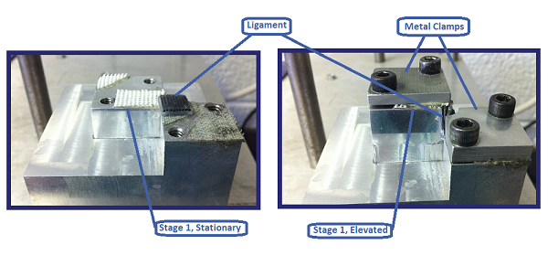Freshly dissected porcine tendons were obtained from a local abattoir and stored at -20C until testing.  Testing specimens were cut to a uniform thickness of 0.5 mm using a cryotome, and were approximately 1 cm by 0.5 cm. 6 quarter-circle specimens were tested using the AQPT. Biaxial tension is induced on the ligament by elevating stage 1 with a motor (see Figure 1). The testing begins with a precycling, which is repeated 5 times, to an amplitude of 5mm at a frequency of 0.1 Hz in a sine wave formation to get rid of the hysteresis in the specimen. Then the stage is elevated at a rate of 0.125 mm/s causing biaxial tension until failure of the ligament. Specimens were kept hydrated by periodic spritzing of PBS solution throughout testing.

Figure 1: Set up and movement of the AQPT.

Force-displacement data was gathered using a load cell located between the motor and the stage. A system identification was performed using iterative search algorithms to identify the combination of anistropic constitutive parameters that provided the closest match to the observed experimental data. The system identification was obtained via nonlinear finite element analysis performed using FEBio.

**Results:**

Post-hoc comparison of the displacement profile of the tendon specimens in both the matrix and fiber directions provided independent validation of the accuracy of the estimated constitutive parameters. Further validation of the estimated constitutive parameters was obtained through comparison to previously obtained uniaxial testing of porcine tendon performed in both matrix and fiber directions, which matched both qualitatively and quantitatively.

**Discussion:**

The AQPT was able to successfully replicate the success of the ASPT methodology. Additional benefit of the technique results from reduced reliance upon precision machining and central punch geometry. Specifically, we anticipate that novice users will be able to obtain excellent results with less sensitivity to hardware concerns.

**References:**

[1] Robertson et al. (2013), Journal of the Biomechanical Behavior of Biomedical Materials 17:34-43.