Animal Model of Intervertebral Disc Regeneration: Camelids

Background:Due to the upright posture and distinct activities of daily living associated with the human condition, the human spine is exposed to a mechanically unique environment. Current animal models for the human spine are helpful on a number of fronts; however an animal model that better represents the mechanical environment experienced by humans would be welcome.

C:\Users\Dean\Documents\1_School\Research\Conferences\ORS 2013\comparison.tifCamelids, specifically llamas and alpacas, present several potential advantages as a new animal model for the human spine. The quality and relevance of an animal model is related to similarities in development, anatomy and cellular interactions [1]. While there may exist slight differences among the geometry or biology of mammalian animals (including humans), similarities of the llama cervical intervertebral disc (IVD) and the human lumbar IVD encouraged investigation of camelids as an animal model to better understand pathologies [2] and treatments for the human lumbar spine. The purpose of the present work was to characterize the torque-rotation behavior of the camelid spine, with the specific goal of comparison with reported human flexibility data [3, 4].

*Figure 1: Select similarities of the human lumbar spine and the llama cervical spine*

Methods: Biomechanical flexibility tests were performed on three cervical functional spinal units (FSUs) from both a llama and an alpaca. Pure-moment loads of 4.0(±0.1)-Nm were applied with (and without) a 50-lb (23-kg) compressive follower-load at a continuous rate of 1-˚/sec in axial-rotation, flexion-extension, and lateral-bending. Three-dimensional rigid body motion was obtained for the upper vertebra, with respect to the lower vertebra, using post-hoc image analysis. Results were compared with published data [4,5].

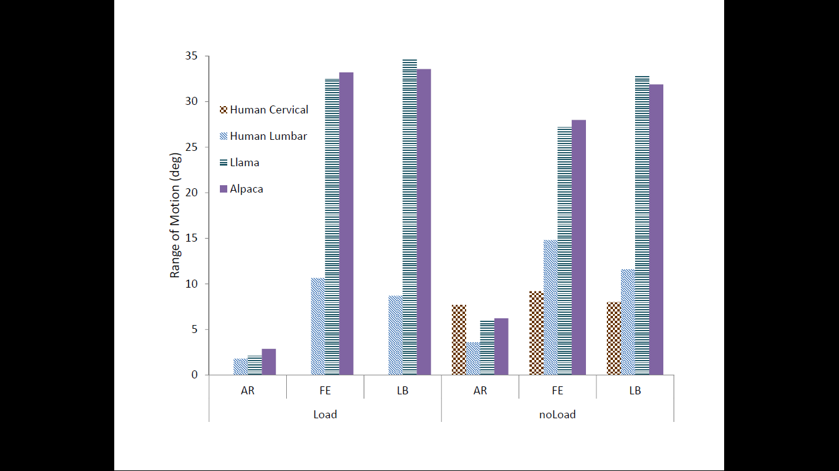Each specimen was imaged to compare morphology/size/shape with human specimen. Images were obtained from anterior, posterior, lateral, and transverse-sectional views. The FSU was separated superior-inferiorly with a transverse cut through the IVD and the facet joint capsule for transverse-sectional images of the superior and inferior segments.

Results: Results from the flexibility studies indicated that ranges of motion for llama and alpaca were very similar in all modes of loading. As compared with reported data for human cervical and human lumbar spine (Figure 2), both camelids had very similar ranges of motion in axial rotation, but substantially larger ranges of motion in flexion-extension and lateral bending (approximately 2X – 3X).

*Figure 2: Flexibility results in primary modes of loading for camelid (llama, alpaca) cervical, human cervical, and human lumbar spinal segments*

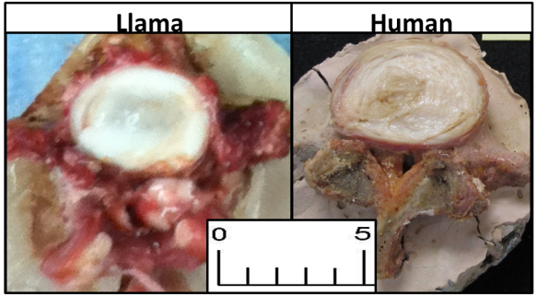Geometrically, llama and alpaca cervical discs were virtually identical in size and morphology to human lumbar discs (Figure 3).

**Discussion**. Functionally, the llama and alpaca are intriguing as potential animal models for spinal behavior as the cervical spine supports vertical loads. Geometrically, the similarities in size to human lumbar spinal discs were surprisingly strong in both width and depth.

*Figure 3: Transverse-sectional size comparison of llama cervical intervertebral disc and human lumbar intervertebral disc (scale bar is in cm)*

Significance: Cervical intervertebral discs of llamas and alpacas show substantial similarities geometrically, functionally, morphologically, and biomechanically to the human lumbar IVD. Initial indications are that they may provide unique advantages as an animal model for studying human spinal behavior.

Acknowledgements: Funding for this project was provided by the National Science Foundation (CMMI-0952758). Any opinions, findings, and conclusions or recommendations expressed in this material are those of the authors and do not necessarily reflect the views of the National Science Foundation.

References: [1] Alini et al. (2008) Eur Spine J 17:2-19. [2] Valentine et al (2004), J Vet Diagn Invest, 18:126-129. [3] Panjabi and White (1990), Lippincott Williams & Wilkins. [4] *REFERENCE BLINDED* [5] Kode et al (2012) Spine DOI: 10.1097/BRS.0b013e31825e6251.